**EUROPEAN UNIVERSITY OF LEFKE**

FACULTY OF ENGINEERING

Graduation Project 2

Computer Based Lottery

### Nader Dali

### 184459

**Short Introduction of your project ( 1-2 paragraph); what is your project, what is the main idea, why will be used, what is the goals . My project is Computer Based Lottery, a web page that sells 100 tickets to people ,then they may win a crypto money if their number is chosen and previous numbers will be kept in the database.**

**The goal of this project is to create an entertainment website which people can buy tickets up to 10 tickets per person(max) , tickets presents random numbers and after they should wait for the winning numbers to show and if their tickets is the winning one they win crypto currency money.**

**Supervisor**

Zafer Erenel

Publish Date

Xx/xx/xxxx

**Table Of Contents**

Nader Dali i

184459 i

Zafer Erenel i

Publish Date i

Xx/xx/xxxx i

1.Introduction 1

1.1 Problem definition 1

1.2 Goals 2

2. Literature Survey 3

3. Background Information 5

3.1 Required & Used software 5

3.2 Other software 5

4. Design Documents 6

4.1 Data flow diagram 6

4.2 Your Context Diagram 6

5. Methodology 7

6. Conclusion 9

6.1 Benefits 10

a. Benefits to users : 10

b. Benefits to me : 10

6.2 Ethics 10

6.3 Future Works 12

7. References 13

# 

# 1.Introduction

## 1.1 Problem definition

My goal from this project is to give entertainment that might cost money , it’s not hard to become hung up on trying to win back lost money because sometimes, like “Computer Based Lottery”, giving hope to people that they might win a fortune is more important than the actual game.

That’s why my users will need and want my project because it will give hope of winning something because that’s what everyone wants, hope and anticipation of the future and see if they are lucky or not.

My project is like a gambling game like a lot of games such Lotto, Bingo, Roulette, Poker, Black Jack,… online gambling became known and most used for the last 2 years and people find it more effective and efficient than going to casino and you can play anywhere and anytime you want.

But the site won’t let minors use this website because it is illegal for a underage people to play this game.

These all gambling games come in many formats, their prize can be a fixed amount of cash or goods.

Usually every player should be assured of winning something,these kind of games are for amusement for people who can afford because there is a risk of losing more than you can win.

Example-Problems :

* Compulsive gambling :
* the uncontrollable urge to keep gambling despite the toll it takes on your life. Gambling means that you're willing to risk something you value in the hope of getting something of even greater value. [1]
* .Influence :
* If your family members or friends have a gambling problem, the chances are greater that you will, too
* Health issues :
* Compulsive gambling may also be associated with bipolar disorder, obsessive-compulsive disorder (OCD) or attention-deficit/hyperactivity disorder (ADHD).

## Goals

Computer based Lottery is a website designed for anyone above the age 18 to enter and use whenever and wherever they want. The purpose of this project is to make people gamble and try their chances and try to win some extra prizes, I’m making this project to make people happy and reduce the stress they had that day , increase their social networking and making their mind more sharp and to make them relaxed and comfortable with my website.

Im going to create a web that contain 100 tickets that anyone can buy up to 10 tickets per person ,

the trick is that this site is using crypto currency, that means people will need to get crypto currency, which crypto exactly, they need to buy tickets using crypto, and they will win crypto money.

I m going to make they won’t be any loser from the 100 tickets bought, there will be always 1 winner from the bought tickets.

* Project goals :
* Happiness: when the player win, it makes you happy and change you whole mood of the day.
* Hope: my project can give you hope of winning something in return , it doesn’t matter if you win or lose .
* Winning: My poject can help you a different kind of prizes
* Stress reduction: let’s say you had a stressful day, this project can help you forget about everything and focus only on it.
* Entertainment : [Studies on the pros and cons](http://www.cam.ac.uk/research/news/the-psychology-of-gambling) of gambling have found that it’s an excellent mood booster that can trigger the release of dopamine. They’ve discovered that the activity can have similar effects to any other source of entertainment like watching TV.[2]

# 2. Literature Survey

My project is a mixture of all kind of gambling games which will make it more interesting for the use to want and use it and try it.

There is a lot of gambling online site which used all around the world which you can use to play where and when you want that’s why making a gambling site interest me because it can benefit people in so many ways .

Gambling sites that are famous are nicobet.com, bet365.com, stake.com, Draftkings.com …

These sites contains all kind of gambling like cards or racing or numbers or betting on sport games and the user(customer) can use which ever they want to use their money on.

In some countries like Turkey, online gambling is illegal therefore they shut off all the gambling sites, once you enter the Turkish border, you can’t use any of these sites.

**Compare1(Lotto & Bingo) :**

Lotto and Bingo which is a kind of gambling which is about drawing of numbers to win a prize , the difference between my project and lotto is that the ticket numbers chosen by the customer is random and in lotto, the customer choose or predict which numbers going to win

**Compare2(Blackjack, Poker and horse betting):**

These kind are gambling types but the difference is that mine are around numbers and luck but these games is all about statistics and strategies.

**Compare 3(Roulettes):**

There is also roulettes which is a wheel and you have to pick a number on a table and after the you put a ball at the wheel and turn it and if the ball lands on the number you choose after the wheel stops you win some kind of prize and the difference between roulette and my project is that my project will be using only the wheel without the ball and save each number at each time the wheel stops and put the number to the data base and print the number at a side table.

# 3. Background Information

You must write which language, tools you use, and why. If you have any hardware you should write them. You can find an example Below do not forget to remove examples !

## 3.1 Required & Used software

Below Is example you should change with your tool !

* **React Native :**

React is good

* **Visual Studio Code :**

Good Code editor.

* **MYSQL :**

MYSQL for database.

* **HTML:**

Structure a web page .

* **JAVASCRIPT:**

Programming language

## 3.2 Other software

* **Git :**
* **ThirdWeb : Contract codes**
* **Tailwindcss**
* **MetaMask: used for crypto currency accounts and codes**

# Design Documents

If you have documents you must put here, your required document ( uml , class , dfd diagram etc…) do not forget to explain them shortly. If you have hardware you can add hardware architecture to. You can see below example Do not Forget Delete Examples !!

## Data flow diagram

Log in, Credit card, security

Balance Information

Customer

Administrator

Computer Based Lottery

System

Balance report

Sell tickets

Buy tickets

Balance information

Members

## Your Context Diagram

# Methodology

When I made graduation project 1, I honestly did not know what I was going to do exactly because I was working in turkey , I worked 12 hours a day and I didn’t have internet at the place I was living at, and I had 2 weeks to submit graduiation, so I made documentation close enough for what I m suppose to for my graduation project .. so I gave it a lot of thought and decided what my project is going to be really about, it’s the same idea but I had improvised and improve it.

In our current generation crypto currency is the next money currency, virtual currency is the future . so I m using this for the computer based lottery .

So I started by creating the page at first using html and tailwindcss that helped me style the page and make effect and visual modification, then I searched how can I include crypto in my project, I found “React” and (9)“Thirdweb” , they helped me with few codes for the contract that helps me to identify the winning tickets and remaining and all relative things, also i found (8)Metamask which is an app that user that create their account to log in to my site, Metamask is where you buy your crypto currency from, there is multiple currencies you can buy using Metamsak. It’s basically a crypto wallet that you save your money or buy from so you can use anywhere you want, gambling sites or stocks or buy things online. I made a lot of mistakes during this project, at this point I still didn’t finish it yet, but im trying to add and try few things to make people and users satisfied with what I have done when im through with it.

Until now I made the log in using metamask application ,which you can downlowd so you can keep up with your account anytime you want and you can play when you want whenever you want.

I also made that the account user Id will be shown on the page when your playing, also the winnings will show which user one using id and the prize will transfer directly to your account shortly after a specific timing. Also I will make a timer that users will have until they need to buy tickets if they want to be in the next draw for the winning ticket. I m going to make sure there will always be a winner .

Using React and thirdweb helped a lot with creating this web site as for the contracts to make no mistakes when it comes to html coding.

For example to it helps you where to import a contract for html so you can be able to use thirdweb in the page and give you head start, as shown below:

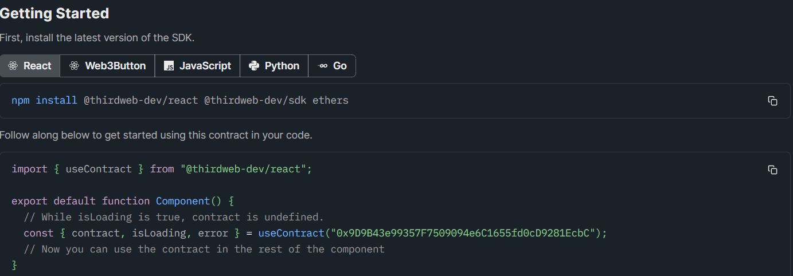

Or it can give the contract that will help you with reading data as shown below:

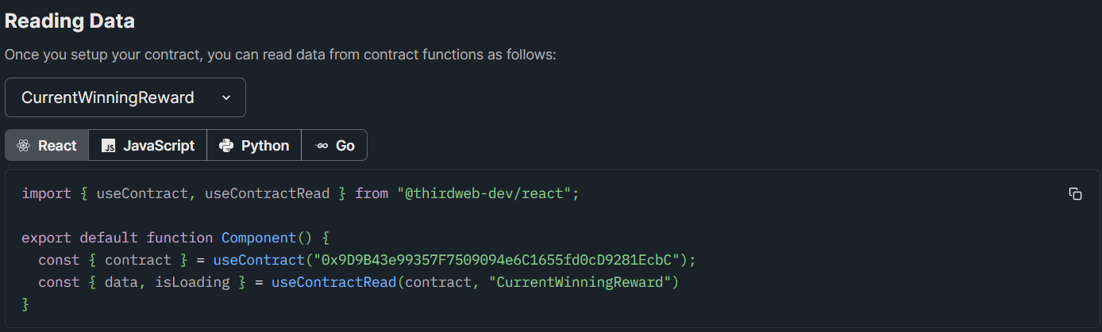

Or writing data for the contract :

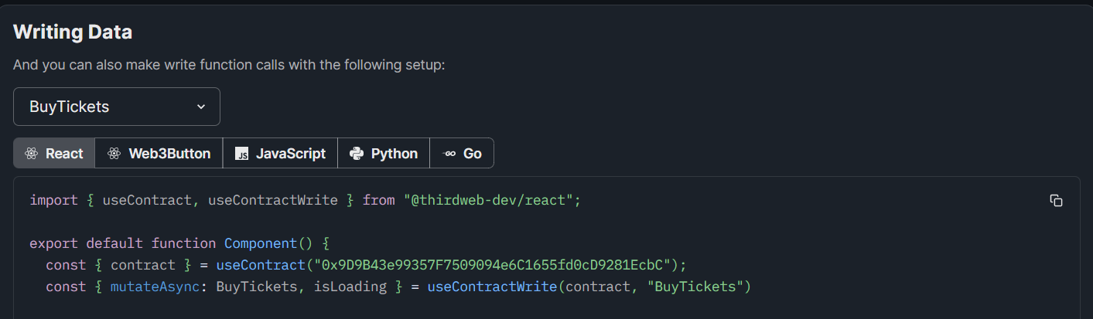

Thirdweb helped a lot when it comes to smart contracts and gives me a small head start to start coding so users or me don’t have any error on the way.

Today I thought about making a countdown for the lottery so users can know when is the next draw so they know when or how much time they have left to get tickets to get in the draw

So I created a component name countdowntimer with the details and the style I needed to be seen in the webpage, then I added it to my UI , still haven’t decided how long each draw is going to be, but I made the timer in hours minutes and seconds just in case I decide to make it a long draw

Also I fixed the webpage because before when I try to minimize the page, it all get mixed up and become not organized, so I made look like it should be, no matter what the size of the page, it will always look organized

Everytime I want to add new components that are related to the application I m making, I always try to implement it to the UI because it helps with the interaction whether with the users or with the webpage .

Today I added the confirmation when the transaction of buying tickets have been made, after selecting the number of tickets the user decide to buy, there is a button “buy tickets” to use then you connect to your metamask and then confirm the transaction.. so for this code I imported “react-hot-toast” to use to show the message if the transaction have been succefull or failed.

Now I added the tickets which the user will see how many tickets he have in the draw after buying n tickets and that’s by running out a number of how many of the address exists belong to the user who bought the tickets and reduce it to number of tickets

To be continued…

You should explain your project in detail, how did you handle the task, what did you do, you can explain your algorithms, important parts of the project which you spend time. If you have hardware and software you can explain their connections, their algorithm. So you should explain all methods which you have used. This part take the most pages on your document. Do not forget give the references. You can use APA 6 Format.

# Conclusion

explain what would be the benefit of this project once completed, also list any tasks you may add to the project in the future

## Benefits

You should explain the benefits for project user

### Benefits to users :

1. Winning prizes

2. Giving hope of getting something in return.

3. Stress reduction

### Benefits to me :

You should explain the benefits to you, what will you learn, etc.

1. Experience

2. Creating new jobs

3. Changing lives

## Ethics

You should explain the ethics of your project area, ethics should be supported with your resources.

* Online gambling can give happiness and encourage good character
* Someone gambling small amount of money online once or twice a week can be classified as virtuous as someone who gambles excessive amounts of money, which means all online players are equal.
* Individual who are ble to control the amount of time and money they gamble are successfully able to achieve the golden mean.
* At roulette game, the players are aware that the chances are favourable to the bank over prolonged piece of play
* Some people consider gambling unethical because it attributed to religious beliefs and stigma of obtaining money relatively for nothing.[3]
* Avoiding legal pitfalls : complying with the law so you won’t end up arrested, making the online gambling legal is to prove that your site comply with everything the law ask for.
* Preserving your reputation ; with so much competition , building an image is based on trust and transparency which ensures that your costumes are more likely to gamble with you instead of others
* Improved customer loyalty; gaining gambles trust by knowing that you will treat them fairly and legally and not take advantage of them matters for them
* In Online gambling there is age restriction before you start playing which is set from 18 or 21 and above and if you don’t fit the age limit you are not allowed to gamble.

**Why did I choose this project?**

These project got my interest because I used to gamble and I knew the feeling of winning and losing so i already knew the advantages and disadvantages of this industry.

This industry have a good income, you can make a lot of money out of it and you can change other people life by winning , giving people decisions to control their own fate give a good feeling. The online gambling is the new era of technology,as much as the crypto currency which is the next generations money that is virtual money that you can use anywhere on anything you want, you can buy anything you want using this currency, I thought this is a good way to keep up with the new generation of technology.

I have always wanted to get involved in the gambling industry and see how it works and know the odds have to win or lose.

I wanted to give better odds to people when they use my project and get more benefits compared to what they used to get in other companies or sites.

## Future Works

are you going to continue this project after graduation, if yes, What improvements will you do? (1-2 paragraph)

I m willing to continue this project if possible , I will try to make new ideas in the online gambling industry and try to be more creative that time and will try to give the gamblers what they want and make it fair and legalize it I will also try to make official so people can use it by using real money and can use any currency to play it. I want to make it a worldwide site so anyone can use it with all languages available and make 24/7 live support system in case users have questions they need answers to.

# References

You should write your references which you found at your research and literature survey. You can use APA 6 Format

* [1] [Book: Mayo Clinic Family Health Book, 5th Edition](https://order.store.mayoclinic.com/books/gnweb43?utm_source=MC-DotOrg-PS&utm_medium=Link&utm_campaign=FamilyHealth-Book&utm_content=FHB)
* [2] <https://review42.com/resources/advantages-of-gambling/>
* [3] www.123helpme. Morality And Ethics: Ethical Issues Of Gambling
* [4]Dervishi, Kay (2019-06-18). ["Other games of chance and skill on Albany's agenda"](https://www.cityandstateny.com/articles/policy/gambling/new-york-games-chance-and-skill.html). *CSNY*. Retrieved 2018-06-25
* [5]Merriam-Webster. (n.d.). Lotto. In Merriam-Webster.com dictionary. Retrieved August 14, 2022
* [6]International Journal of Ethics , Jan., 1905, Vol. 15, No. 2 (Jan., 1905), pp. 135- 148
* [7]<https://www.yogonet.com/international/news/2020/05/27/53377-the-benefits-of-being-an-ethical-online-gambling-operator>
* [8] :  **https://metamask.io/**
* [9]: https://thirdweb.com/